**Question 1:** A hexagonal pyramid of base side 20 mm and axis 50 mm long, rests with its base on HP and an edge of its base is perpendicular to VP. It is cut by a section plane perpendicular to VP, inclined at 30˚ to HP and passing through a point on the axis 14.5 mm below the apex. Draw the sectional side view and sectional top view.

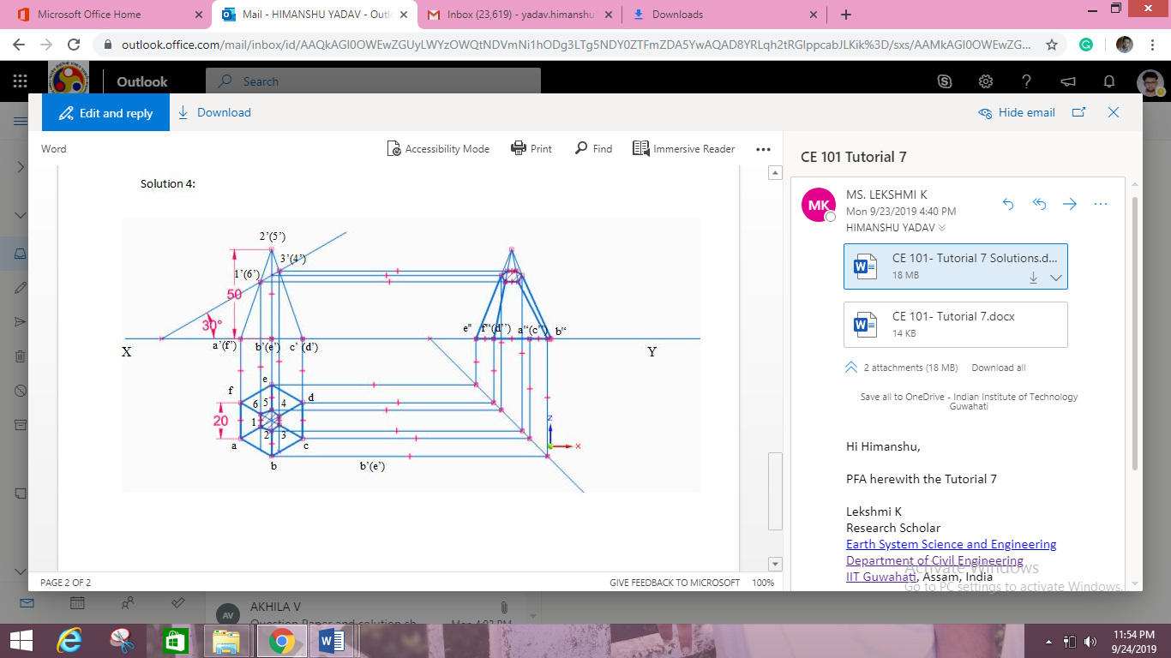

**Question 2:** A pentagonal pyramid of 30 mm base and 60 mm axis length lies on HP on its base edge such that one of the slant faces is perpendicular to both HP and VP. Draw its projections, including side view, when it is cut by a section plane parallel to HP and at a distance 20 mm from apex point.

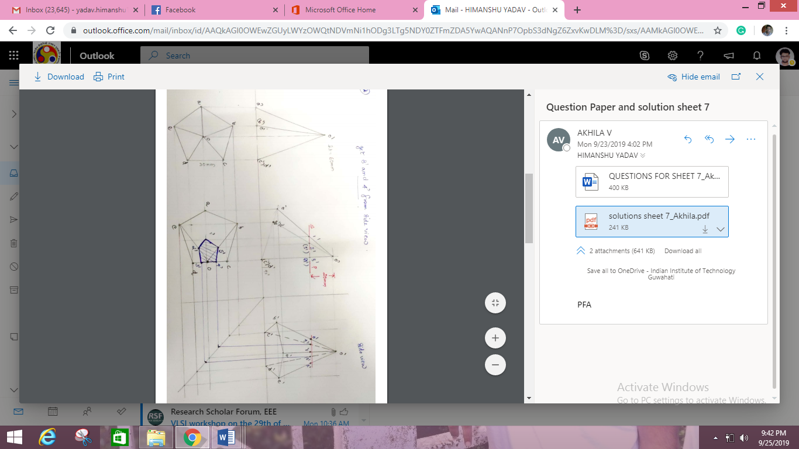

**Question 3:** A cone of base 60 mm diameter and axis 70 mm long, resting on HP on one of its generators with its axis parallel to VP. A horizontal sectional plane bisects the axis of the cone. Draw its top view and sectional front view.

